**Krikey User Analysis**

The purpose of this app is to provide entertaining content to the customers of the app. To better serve them we need to understand where they are, their habits, and how they interact with other users.

This analysis starts with finding where these customers are at. These customers are located all across the globe in more than 100 different countries. This map shows the hotspots of where they are located. This is very impressive considering that this only contains the growth of about a year’s worth of data. By looking more into the growth over time it is clear that most of the countries with the most users follow similar trends. There seems to be some events that cause new users to join in the major markets in July and October/November. It may be interesting to look into what company changes happened at these times and see if a replication of the event may cause another jump in new users in that time frame. 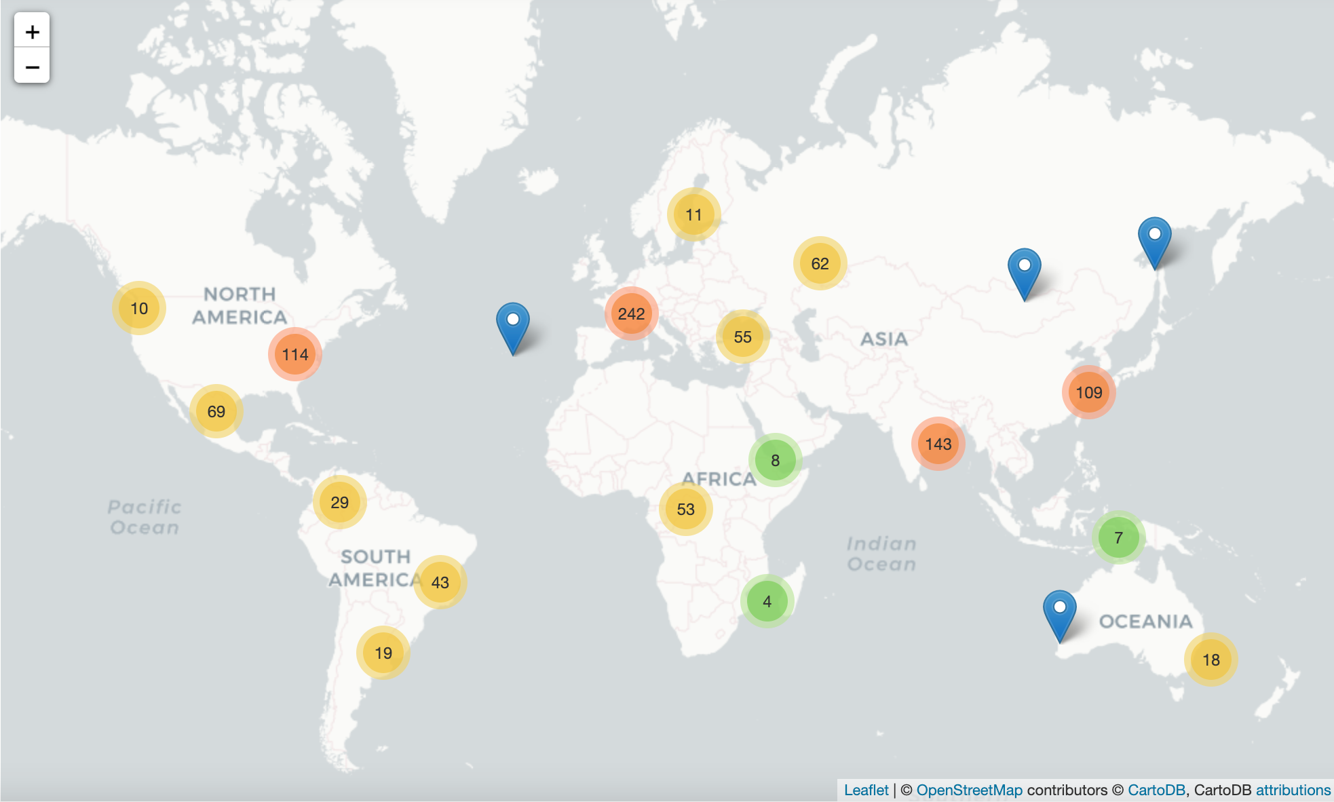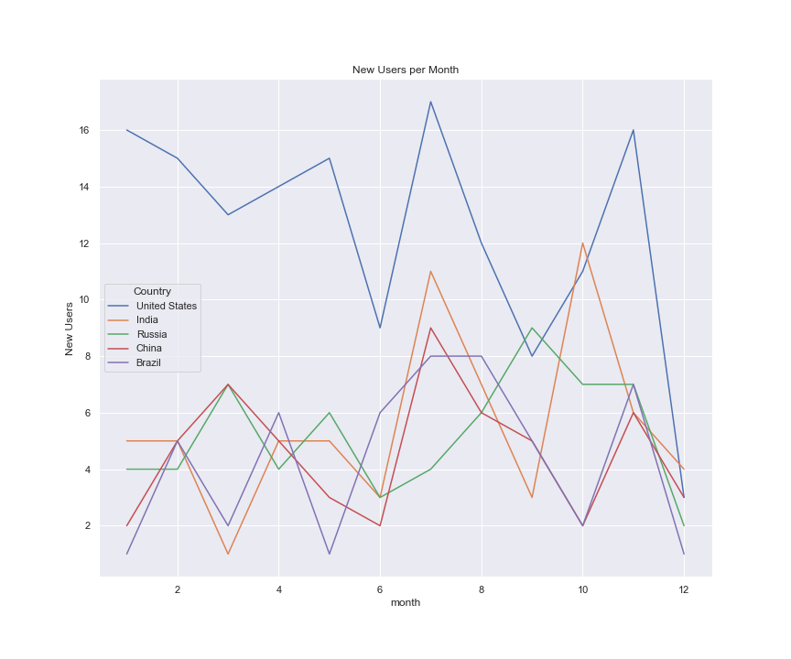

After finding where these customers are, it is important to try to understand these customers and different habits that they have. I thought it would be interesting to see the average views and videos posted per user in these top markets. For the most part the users created about 5 videos and watched about 50 across all the top countries. This is the trend for countries that have far less users than the United States as well so it is likely that this is just a trend for most users. After finding that the average user will both create and view videos, I wanted to look at the distribution of the users in the different classes, specifically the gaming class. These users range from being about 35%-60% of the population of users in the top countries. These users most likely have a lower than average video creation number than the other categories. To increase their video creation it would be a great feature for them to be able to post highlights from the games that they are playing. This would help them to produce more content and increase the content pool that other users could consume. 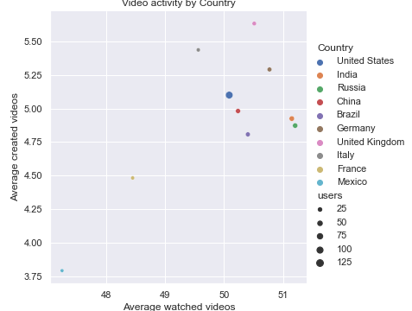

Users interact with each other through viewing each other’s videos and sharing videos. To see the relationship between these two types of user interactions I created a linear regression model of average view time duration and number of shares per video. My focus was to find the correlation and the statistical significance. This analysis did not show that either value was significant and it is clear that these aren’t correlated from a scatter plot of these values. I noticed that most of the videos I saw on the feed had relatively low likes. I think that it would be interesting to create an analysis of the number of likes over time. It would be able to show if a video is trending quickly or slowly and would show if the video was maybe trending quickly to start, but then started to cool off. This could be useful when recommending videos for other users to watch. 